|  |  |
| --- | --- |
| **Name** | **Adham Mohamed Salama Mahmoud** |
| **B.N** | **161** |
| **Topic** | **Mobile computing** |
| **Github link** |  |
| **Github page** |  |

# **Application brief:**

**Hello**

**I chose this topic which is very important this days its about mobile computing and I inserted tables list ordered and unordered and images and low CSS to center the images**

**I hope I could match this topic as possible as.**

# **Screenshots:**

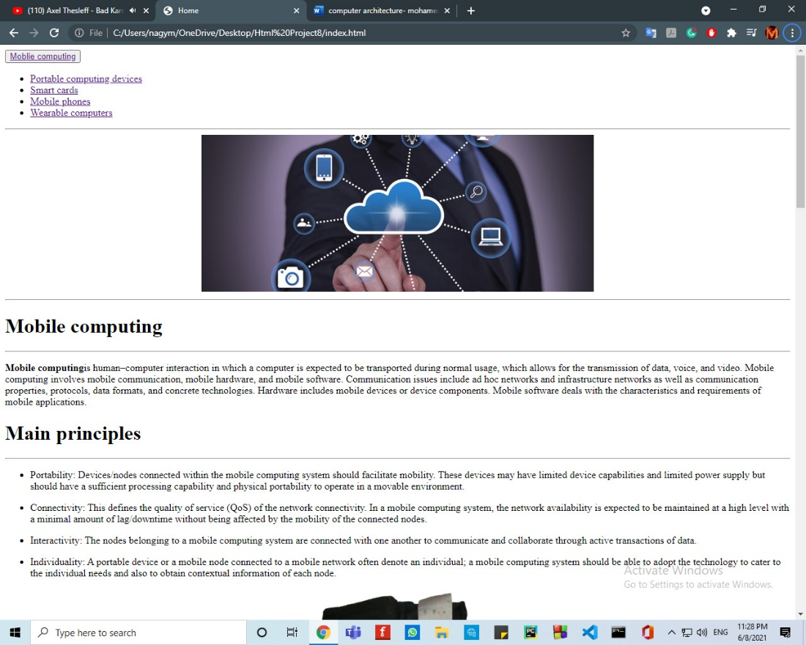

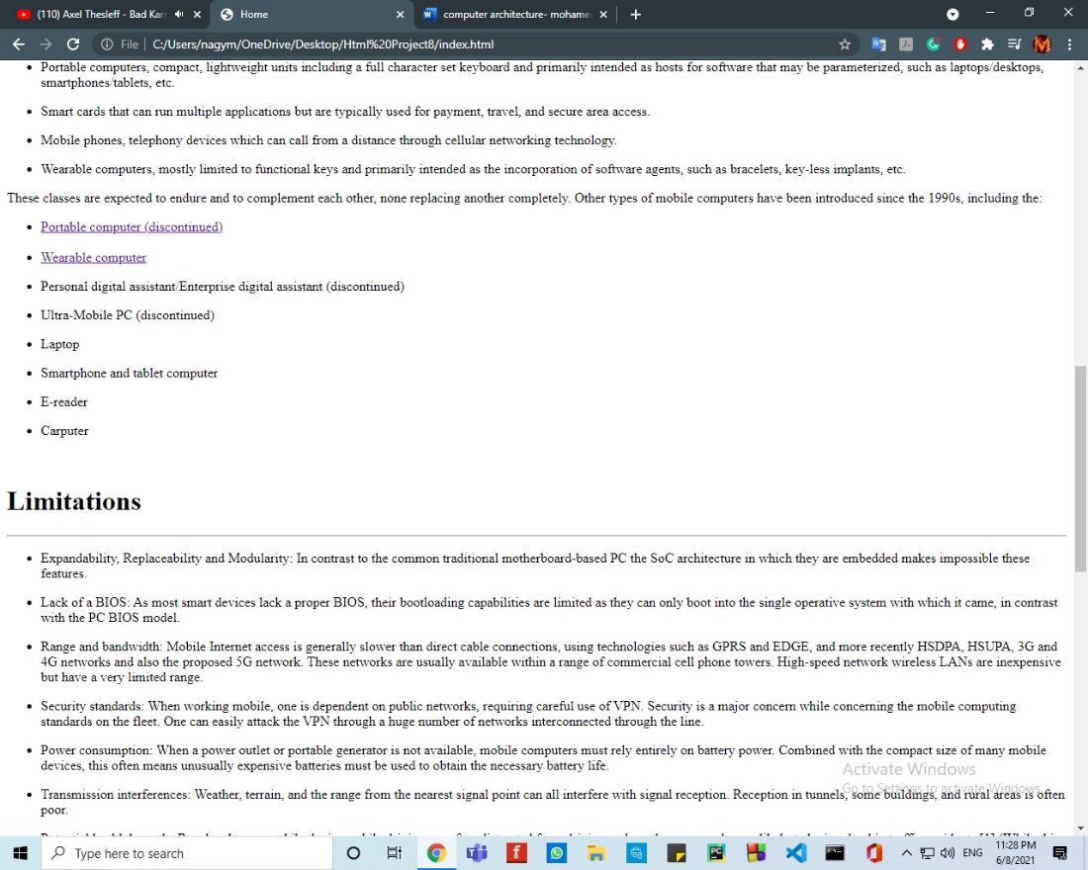

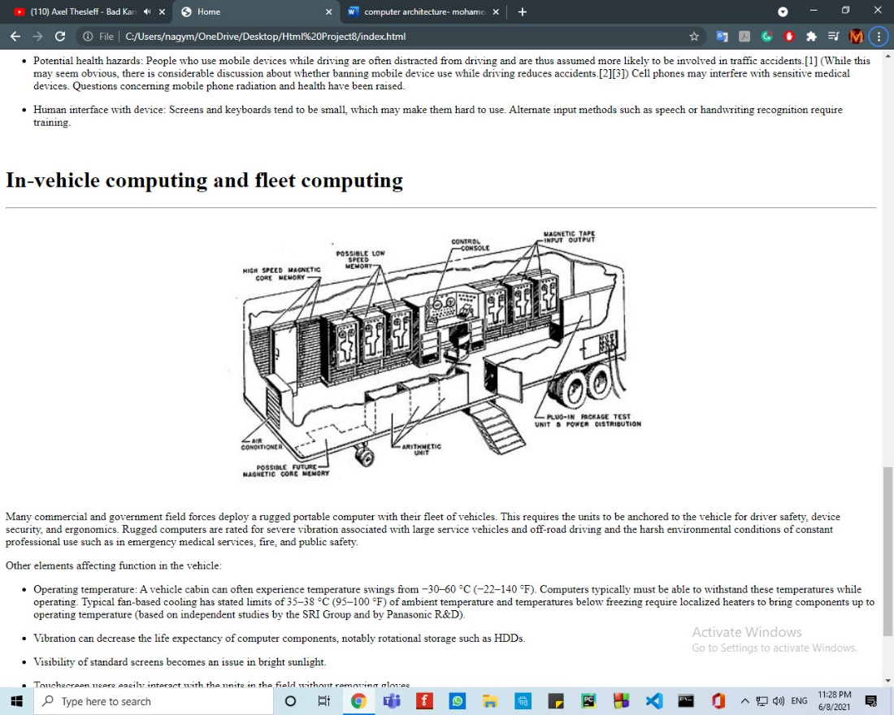

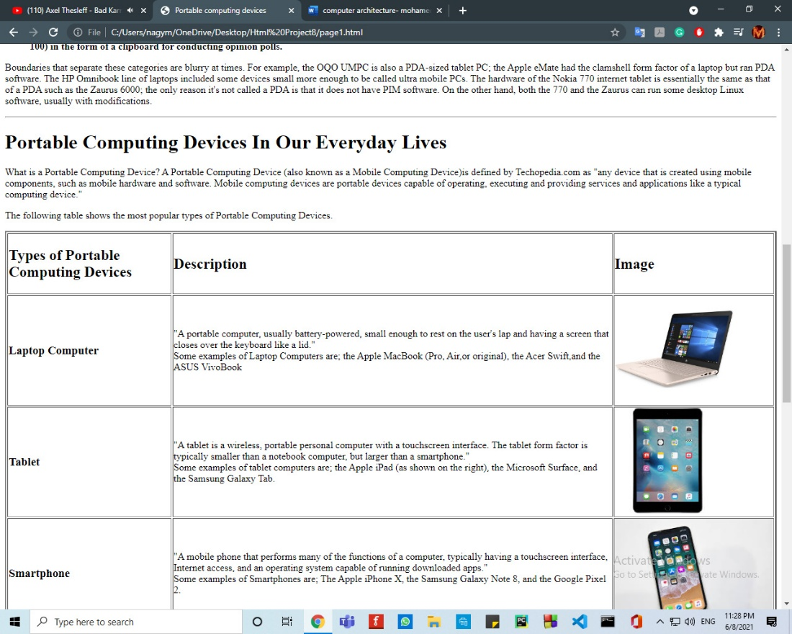

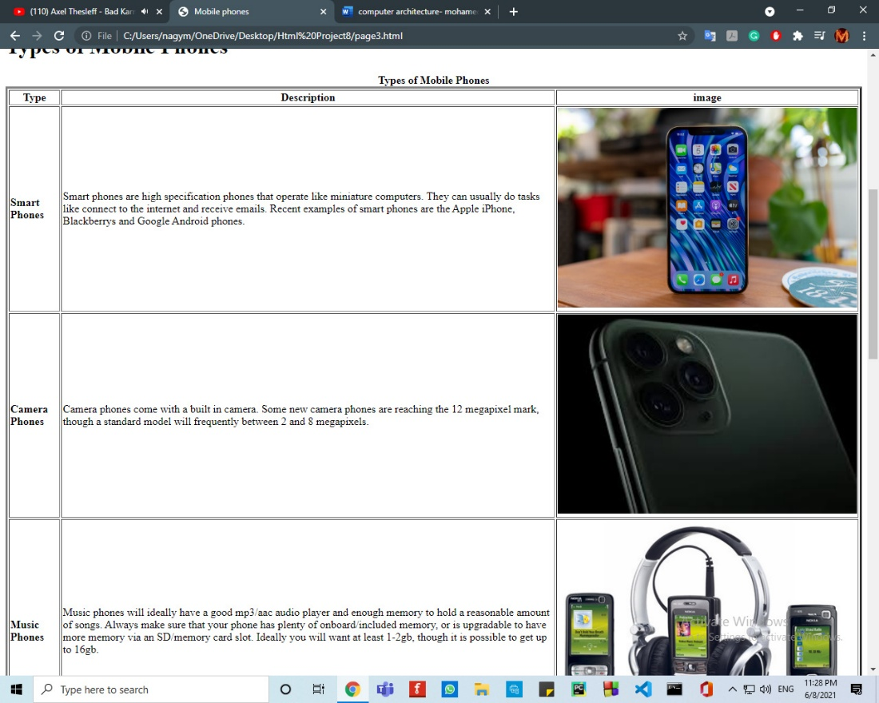

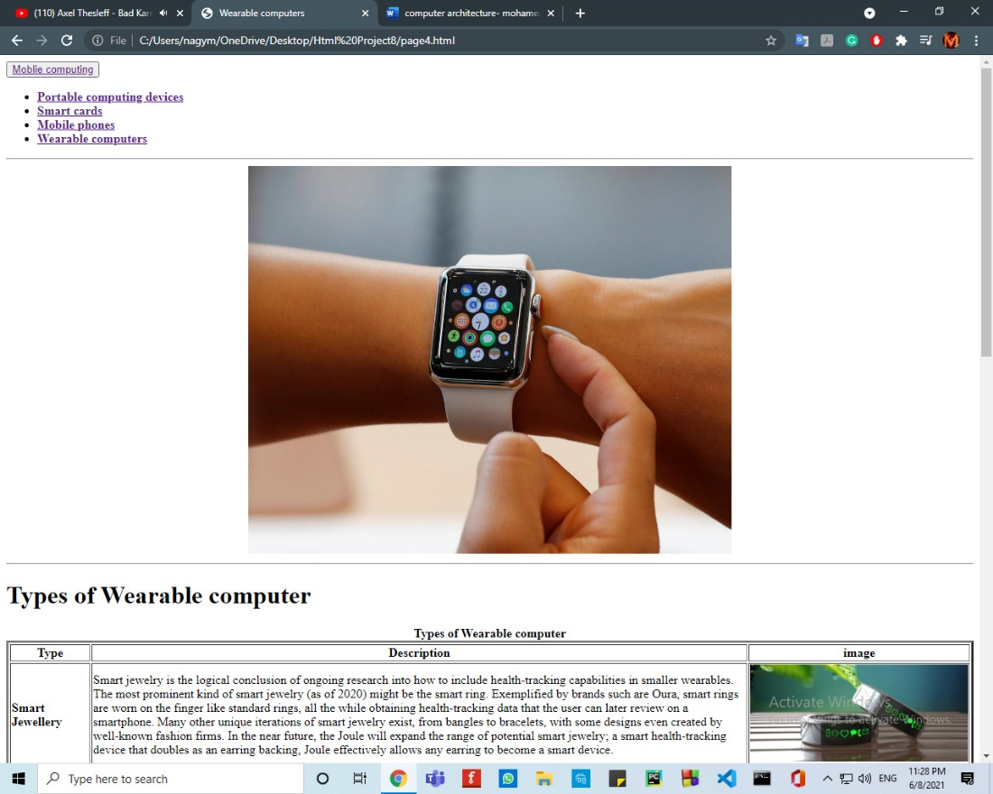

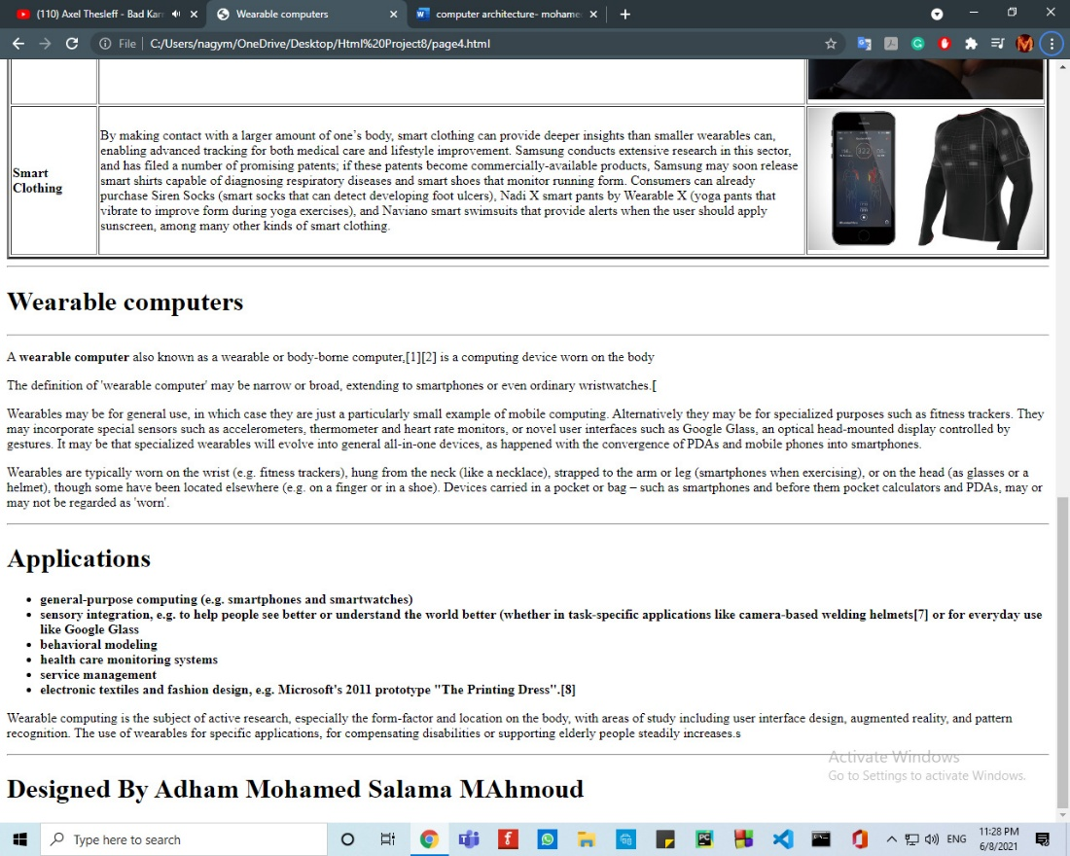

# **Source:**

